A NON-CONTACT BASED SYSTEM TO MEASURE SPO2 AND SYSTOLIC/DIASTOLIC BLOOD PRESSURE USING RGB-NIR CAMERA

by

DIVYA SAXENA

Presented to the Faculty of the Graduate School of

The University of Texas at Arlington in Partial Fulfillment

of the Requirements

for the Degree of

MASTER OF SCIENCE IN COMPUTER SCIENCE

THE UNIVERSITY OF TEXAS AT ARLINGTON

May 2022

Copyright © by Divya Saxena 2022

All Rights Reserved



# Acknowledgements

I would like to express my deepest gratitude to my advising professor Dr. Manfred Huber (PhD, Computer Science), for providing me with the opportunity to work under his supervision in his lab. It was his altruistic motivation and guidance, which always inspired me to achieve the best and helped me to complete my research. I would like to thank my committee members professor Dajiang Zhu and professor David Levine for their support and guidance in my research. I would like to thank the CSE department for providing me with the infrastructure and lab to support my research. I would like to thank all professors and teaching staff whom I directly or indirectly contacted to clear my concepts. Without their help, I would not have been able to achieve the knowledge and education which I have today.

Finally, I would like to thank my parents whose prayers have got me here. Their belief in my vision helped me achieve my goal. I am also extremely grateful to my friends who stood by me patiently during the research.

May 13, 2022

# Abstract

A NON-CONTACT BASED SYSTEM TO MEASURE SPO2 AND SYSTOLIC/DIASTOLIC BLOOD PRESSURE USING RGB-NIR CAMERA

Divya Saxena, MS

The University of Texas at Arlington, 2022

Supervising Professor: Manfred Huber

In recent times, people have increasingly self-assessed their health using different devices on their bodies that monitor physiological attributes such as their oxygen level and blood pressure (BP) to monitor their health. One of the most popular health concerns that became prominent during the COVID-19 pandemic was the blood oxygen saturation (SPO2) level. It became increasingly important to monitor SPO2 in patients, time and again to determine whether the right amount of oxygen is in the blood. Low oxygen levels usually indicate there may be an issue with oxygen circulation or supply and thus informs diagnostic and treatment decisions such as transfer to the hospital or ICU or the application of external oxygen.

The use of existing devices requires active interaction of the user to obtain the information about blood flow needed for SPO2 or blood pressure measurements. However, a change in skin color could also provide information whether a body has a healthy blood flow or not. Skin color can easily be captured with the help of conventional cameras under different lighting conditions. However, under insufficient lighting, it is strenuous to capture accurate images. A digital camera with the ability to capture near Infrared (NIR) images can help resolve this issue by allowing for better illumination control without inconveniencing the user. If blood flow information can be effectively extracted, RGB and NIR image sequences can be used to estimate blood oxygen level (SPO2), systolic blood pressure (SBP), and diastolic blood pressure (DBP).

In this study, methods are proposed that estimate various health parameters like blood oxygen saturation (SPO2), systolic blood pressure (SBP), and diastolic blood pressure (DBP) from multi-spectral video. An RGB-NIR camera was used to record the data. Colored and near-infrared images from the camera have been recorded to extract blood-related health details. Using the existing Photoplethysmography technology that is widely used in commercial devices for measuring oxygen saturation, and BP, we analyzed the photoplethysmogram (PPG) signals using an RGB-NIR camera. The camera was placed at an approximated distance of 3 meters from the subject. For our research, we recorded the subject’s facial area. Furthermore, we analyzed the traditional red, green, and blue channel combination, as well as the additional IR channel. The results were obtained using a multi-spectral camera with a frame rate of 30 Hz per second.

Preliminary results showed statistically that an RGB-NIR camera could potentially be an efficient alternative to conventional medical devices to measure SPO2 and BP, achieving good prediction accuracy for SPO2 and diastolic blood pressure while lacking somewhat in the prediction of systolic pressure. The system proposed is convenient, safe, contact-less, and cost-effective. The pandemic is still rampant and with many companies resorting to contact-less services, it is only necessary and smart to have a contact-less method of arterial oxygen saturation and BP estimation. This technology has significant potential in advancing healthcare.

Table of Contents

Acknowledgements 3

Abstract 4

List of Illustrations 8

Chapter 1 Introduction 1

Chapter 2 Related Work 3

2.1 Blood Oxygen Saturation 3

2.2 Blood Pressure 3

2.3 Our Approach 4

Chapter 3 Background 5

3.1 Photoplethysmogram (PPG) 5

3.2 PPG signal and absorption of light 5

Chapter 4 System Overview 7

4.1 RGB-NIR Camera 7

4.2 LED lamp 8

4.3 Illuminator for IR  8

4.4 Fingertip Oximeter 9

4.5 Sphygmomanometer 10

Chapter 5 Methods 12

5.1 Data Capture and Facial Landmark Extractor 12

5.2 Extract signals 13

5.3 Pre-processing (RGB-NIR Camera) 14

5.4 Feature Extraction (RGB-NIR Camera) 16

Chapter 6 Extra Steps for Blood Pressure 18

6.1 UCI Dataset 18

6.2 Pre-Processing (UCI Dataset) 19

6.3 Feature Extraction (UCI Dataset) 20

6.3.1 Minimum Point and the Systolic Peak Detection [9]: 20

6.3.2 Maximum Slope Point Detection [9]: 21

6.3.3 Diastolic Peak Detection: 21

Chapter 7 Blood oxygen saturation 22

7.1 Proposed Method (SPO2): 22

Chapter 8 Blood Pressure 25

8.1 Proposed Method (BP) 25

8.2 Training and Testing Models 25

Chapter 9 Results 26

9.1 Oxygen Saturation Results 26

9.2 Blood Pressure Results 27

Chapter 10 Conclusions and Future Work 29

References 30

Dataset References 34

Biographical Information 35

List of Illustrations

Figure 1: PPG Signal 5

Figure 2: System Setup 7

Figure 3: AD-080-GE Multi-Spectral Camera 7

Figure 4: LED light 8

Figure 5: ES – IR1206U IR Illuminator 9

Figure 6: FS20F Fingertip Pulse Oximeter 9

Figure 7: OMRON M6 sphygmomanometer 10

Figure 8: Data Capture sample from multi-spectral camera 12

Figure 9: Bounding boxes( ROIs) in left and right cheek 13

Figure 10: Visualizing 68 facial landmarks coordinates 13

Figure 11: Filtering of signal 15

Figure 12: Aligning Red and IR channel 15

Figure 13: Signal Extraction from video images 16

Figure 14: Training Dataset for Systolic BP 18

Figure 15: Training Dataset for Diastolic BP 19

Figure 16: Pre-processing (UCI Dataset) 19

Figure 17: Feature Extraction (UCI Dataset) 20

Figure 18: Absorption coefficients of Oxyhemoglobin(HBO2) and De-Oxyhemoglobin(HB) for different channels 23

Figure 19: Slope of the rising edge of the systolic peak mλ and the height of the peak Vpλ 23

Figure 20: Training and Testing Models 25

Figure 21: Pulse oximeter Reading sample 26

Figure 22: BP reading sample 27

List of Tables

Table 1: Channels, their wavelengths and radiant power 10

Table 2: Comparison of results(SPO2) 26

Table 3: Results by Different Models 28

# Chapter 1 Introduction

Photoplethysmography (PPG) is a non-invasive method that uses changes in light reflection and absorption to measure blood volume changes in a human body [10]. To get the desired health parameters for health analysis, there are multitudes of medical equipment available worldwide. However, for many of them the human body cannot be subjected to these conventional devices time and again or on a continuing basis due to various reasons like the need for and impact of direct contact with human skin, inconvenience to use, obesity (restriction in sizes of medical devices), etc. These devices can be uncomfortable for many patients and, if packaged in mobile devices, often impose run-time limitations due to limited battery life. Conventional methods are difficult to use, for example, if the patient’s skin is too sensitive or burnt and some patients might not be very cooperative, resulting in missing or incorrect readings. Thus, a faster and more convenient technology or device is required to obtain this valuable health information. Moreover, alternative technologies can help address shortages in existing devices such as occurred during the covid-19 pandemic. In this context the ability to share devices across individuals without the risk of infection wold also be a significant advantage, which makes it all the way more important to investigate contact-less medical devices. Similarly, combining multiple measurement capabilities into a single device also provides advantages and makes the system more convenient to use. A non-contact system with multiple measurement capabilities will help record a patient’s profile and report the patient’s health. Due to evolving technology in cameras leading to higher resolution, higher frame rates, and lower noise under varying illumination conditions, use of cameras could be a very affordable solution.

To obtain important physiological information from optical sensors, a number of methods can be used. Photoplethysmography is very efficient in measuring cardiovascular blood volume pressure (BVP) which allows to estimate systolic blood pressure (SBP) and diastolic blood pressure (DBP) via the light transmitted through or reflected from the human body [1]. Cardiovascular diseases can be identified with the help of PPG and significant health information can also be revealed with the help of devices using PPG[2], [5], [6], [7].

The pulse generated via PPG reveals the systolic peak, dicrotic notch, and diastolic peaks. The systolic peak in the pulse wave is represented by the maxima which comes from the direct pressure wave which travels from the left ventricle to the periphery of the body. The diastolic peak is generated due to the reflections of the pressure wave by the arteries in the lower body. The dicrotic notch marks the end of the systole and the beginning of diastole in the pressure waveform [3].

PPG signals extracted at multiple different wavelength of light can also be used to estimate SPO2 values as oxinated and deoxinated haemoglobin in red blood cells have different absorption properties, thus affecting the amplitude of the PPG signal differently at different wavelengths.

While traditionally recorded with devices that are put in direct contact with the skin to void skin reflectivity and glare, PPG measurements can also be used to derive predictions using the signals derived from camera images. Conventional methods for SPO2 mainly utilize two separate wavelengths whereas we will be using four wavelengths – red, blue, green, and NIR since every single detail is conducive for diagnosis.

In the remainder of this thesis we will first discuss related work in Chapter 2 before introducing the background underlying the estimation of blood pressure and SPO2 from optical signals in Chapter 3. Chapters 4 and 5 then introduce the setup and methodology used before Chapters 6 and 7 presents results for oxygen saturation (SPO2) and blood pressure, respectively. Chapter 8 finally concludes the thesis and discusses potential extensions and future work.

# Chapter 2 Related Work

## 2.1 Blood Oxygen Saturation

Blood oxygen saturation can be estimated using a smartphone rear camera [10, 14], front camera [15], or sensors dedicated to SPO2 measurements [16]. The data are usually recorded from the finger or face. This data is then processed into  photoplethysmogram (PPG) waveform. Using the smartphone’s built-in accelerometer is one other device to measure the heart’s mechanical activity (the seismocardiogram or ballisto- cardiogram) [17, 18]. These signals are filtered using Principal Component Analysis (PCA) [17], quadratic spline decomposition, or continuous wavelet transform. Then, they are searched for peaks [19].

The SPO2 ranges from 96-100% [20] for a healthy human being. It is also measured by the Pulse oximeter. The Principle lies the same to calculate the SPO2 level. Both depend on the PPG signal. This PPG signal detects blood volume changes. Using a smartphone for calculation is very simple and cost-effective. It uses Red and Green wavelengths. PPG feature extraction helps evaluate the oxygen level. A number of mathematical approaches have been used for the estimations [21].

## 2.2 Blood Pressure

The arterial blood pressure is measured at two extremes. One is  the highest (systolic) and the other is  the lowest (diastolic) [22]. These values vary around 120/70 mmHg [22]. The most common restriction-free method for estimation is by using smartphones. They measure pulse transit time (PTT) [23, 24]. PTT is defined as the time taken for the arterial pulse pressure wave to travel from the aortic valve to a peripheral site.  It is directly related to the elasticity of the blood vessels. More elasticity means less BP and less elasticity means more BP [24]. The signals used to measure can be ECG, PCG, or PPG. BP can be calculated using the equations in [23]. Some methods use one, two, or three signals with machine learning algorithms [25, 26].  Dey [26] developed the Android application InstaBP for BP monitoring using a PPG sensor integrated into the flagship Samsung smartphone models. The technique of Luo et al. [15] records the video of the face, extracts 126 features and adds 29 meta-features, and uses the multilayer perceptron machine learning method. Chandrasekhar et al. [23] recently introduced the innovative oscillometric finger pressing method. The authors utilized the iPhone X with a strain gauge array under the screen (3D Touch), which measures the pressure of fingertip placement.

## 2.3 Our Approach

In contrast to most of the prior approaches, the work in this thesis is aimed at a completely contact-less way to extract both SPO2 and BP using a multi-spectral camera that permits use of colored and IR image streams simultaneously. It does so by estimating PPG parameters and utilizing them in SPO2 and BP prediction approaches.

PPG is based on the measurement of rapid fluctuations in light absorption in the illuminated area of ​the skin caused by the difference in absorption curves between oxygenated and de-oxygenated blood. This principle motivated the use of digital cameras to measure the PPG signal of facial video under ambient light conditions. Several methods have been developed over the years to estimate heart rate, SPO2 and blood pressure from face video. In particular, [13] provides a comprehensive overview of the history of research in this area and compares the performance of several of these approaches. Most of these methods usually require a lighting source. We need to manipulate and control the signal acquisition process. A controlled light source or an object that remains stationary during acquisition.

The integration of modern infrared (IR) cameras into many traditional devices, makes it particularly attractive for remote monitoring related to iHR, SPO2 and BP detection. Their use has only been investigated in detecting HR and SPO2 using infrared facial video [27], but so far these approaches have been used for a considerable period of time (more than 30 seconds) and it was limited to estimating average heart rate. This thesis shows that under moderately controlled conditions, blood oxygen saturation and even blood pressure can be extracted from multi-spectral cameras using both infrared and colored images.

We will discuss this approach and show performance in color and IR video recorded by multi-spectral cameras from five healthy volunteers. The extracted SPO2 and BP values are compared with the oximeter and spyganometer measurements obtained at the same time.

# Chapter 3 Background

In this section, we briefly review the PPG signal and its key features used for SPO2 and BP estimation in this paper:

## 3.1 Photoplethysmogram (PPG)

A Photoplethysmogram (PPG) contains a few key points like maximum slope point, inflection point, dicrotic notch, and diastolic peak. When the blood travels from the left ventricle towards the face, we can detect a systolic peak; while a diastolic peak is obtained from blood pressure reflected from small blood vessels. The Photoplethysmogram (PPG) is a popular monitoring method since it is easy to measure and provides multiple vital measurements from a single signal. Since we aim to measure BP and SPO2 we are looking to maximize the utility of the signals we receive from the RGB-NIR camera. Figure 1 shows the sample PPG signal.

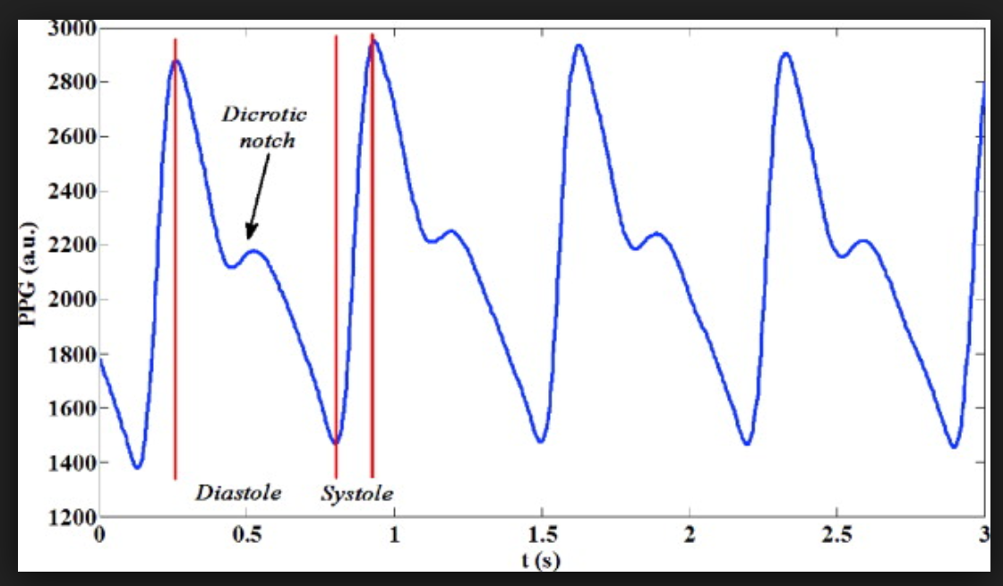  
Figure 1: PPG Signal

## 3.2 PPG signal and absorption of light

Smartwatches and fitness bands have increasingly become popular due to their simplicity and affordability. The PPG technology is very simple. It works based on the light passed through the skin. PPG relies on measuring the rapid variations in light absorption in an illuminated skin region caused by the difference in absorption curves for oxygenated and non-oxygenated blood. The amount of absorbed light is proportional to the blood volume flow in the exposed area. The volume of the blood is related to the speed with which blood flow and pressure are exerted on the arteries, it is prominently used for the measurement of SPO2 and BP. PPG signals can also be effectively used to determine the absorption of oxygen in the blood. The waveforms generated from PPG have a good correlation with the BP waveform. It is also established that PPG alone can be used to monitor blood pressure for a long period [19].

PPG signals are easier to capture than, for example constrictive blood pressure measurement or electric ECG measurements, and the technology is a low-cost technology. There could be other applications of PPG than just cardiovascular assessments. The PPG waveforms generated from the application can also be utilized for varied purposes to detect other pertaining issues in humans like hypertension, lung function, etc.

# Chapter 4 System Overview

In this section, we elaborate on the setup used to create the dataset. We use an AD-080-GE multi-spectral camera to record videos for each subject. We record videos each of 30 seconds, where the resulting video is recorded as two synchronized files, one colored, and the other near-infrared. Figure 2 shows the system setup. We need multi-spectral camera, LED lamp, IR Illuminator, Oximeter and Sphygmomanometer. After this, we detect the face and divide it into different region of interest (ROIs) to extract signals which are then processed to estimate SPO2 and blood pressure values

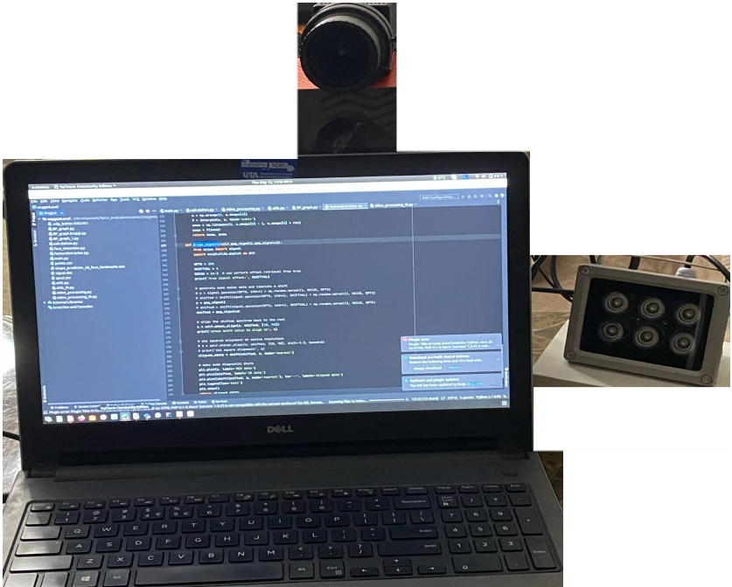  
Figure 2: System Setup

## 4.1 RGB-NIR Camera

We use AD-080-GE camera to record videos for each subject. We record videos each of 30 seconds, one is colored, and the other is near-infrared synchronously. We will save the videos in .raw format to save data loss while saving in compressed format.

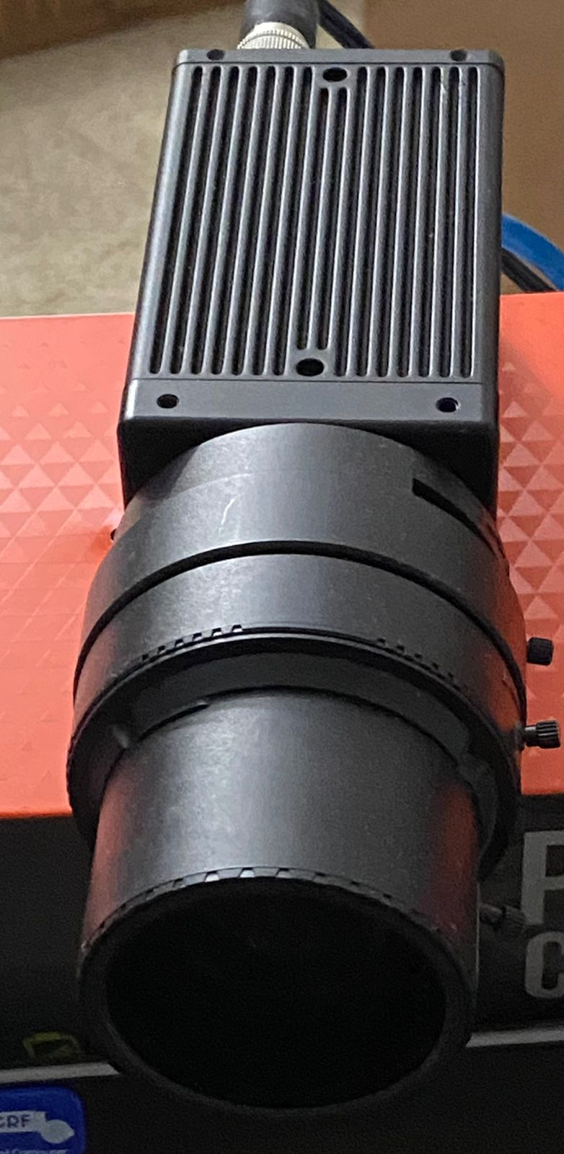  
Figure 3: AD-080-GE Multi-Spectral Camera

## 4.2 LED lamp

A good light source is needed to capture colored images. A led light has been used to maintain same brightness throughout the recording.

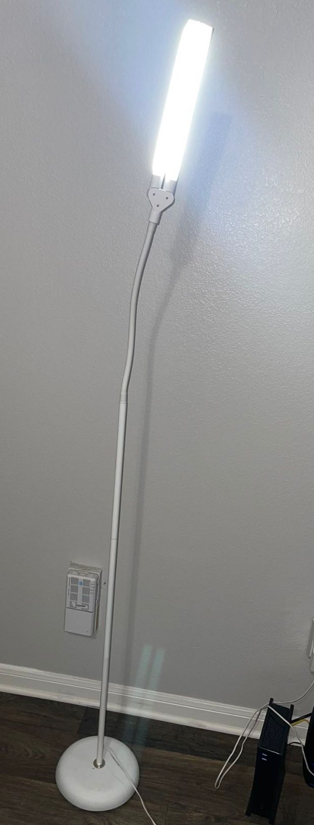  
Figure 4: LED light

## 4.3 Illuminator for IR

Here we propose to use a camera-based remote PPG application that requires sensing in the colored and NIR spectrum [20]. On this data we conduct multi-wavelength processing for signal extraction. Both color and IR channels in the camera enable contactless measurement of the cardiac pulse depending on the subtle color and intensity changes on the skin surface that result from changes in absorption and reflection in the blood vessels directly below the skin [20]. As a normal indoor environment contains very limited amounts of NIR light, an IR illuminator tool is used to emit light in the infrared spectrum. While this adds an additional element, it allows much more detailed elimination control in the IR spectrum than in the color spectrum without inconveniencing the user (since the IR light is not visible). To obtain good and uniform illumination, it is important to choose the right kind of angle to match the lens field of view (FOV). For an effective range, it is important to have the IR illuminator set at a specified angle for our proposed work. For blood oxygen saturation and blood pressure estimation, we need to measure at least one infrared wavelength. Illumination using an illuminator is essential for the accuracy in the measurement of the key features of PPG waves.

Figure 2 shows the basic setup used for the experiments in this thesis. An illuminator at a wavelength of 940nm is chosen to fit the camera characteristics as well as to align with properties of hemoglobin absorption. The individual here sits in front of a computer and the camera while measurements are taken. ES – IR1206U Illuminator has been used in this work.

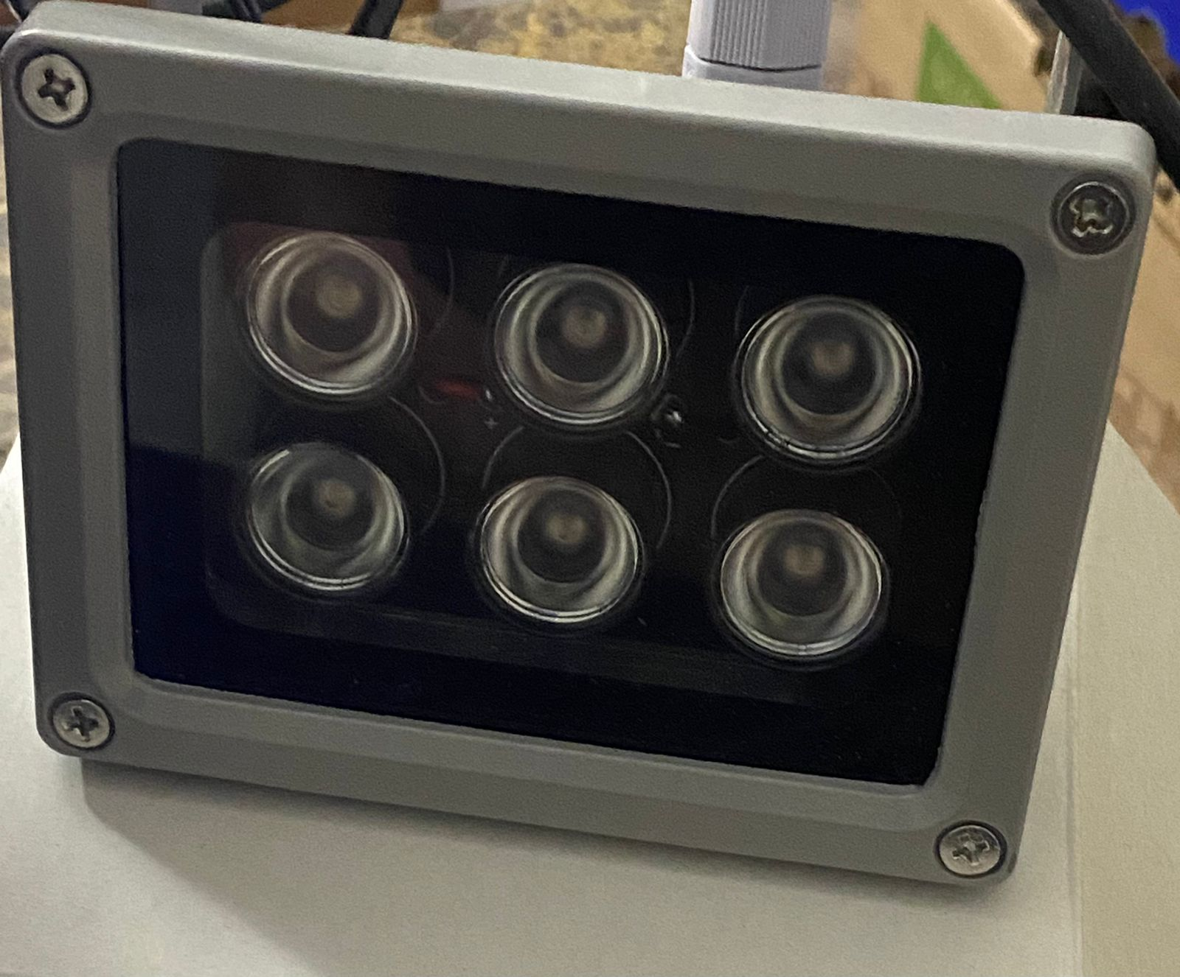  
Figure 5: ES – IR1206U IR Illuminator

## 4.4 Fingertip Oximeter

1. A commercial pulse oximeter FS20F Fingertip Oximeter has been used as ground truth signal in our experiments and its values were compared to the readings obtained by the RGB-NIR camera. SPO2 is an important bio-parameter for respiration and as such, being able to estimate it is an important capability for a sensor system. Some diseases relating to the respiratory system may cause a decrease in oxygen in the blood. Some other causes include damage during surgery and human body self-adjustment. Some more symptoms resulting from a drop in SPO2 levels include vomit, vertigo, etc. These symptoms may be a danger to the life of human beings. It’s a great help to doctors to discover potential dangers and importance in the clinical field.

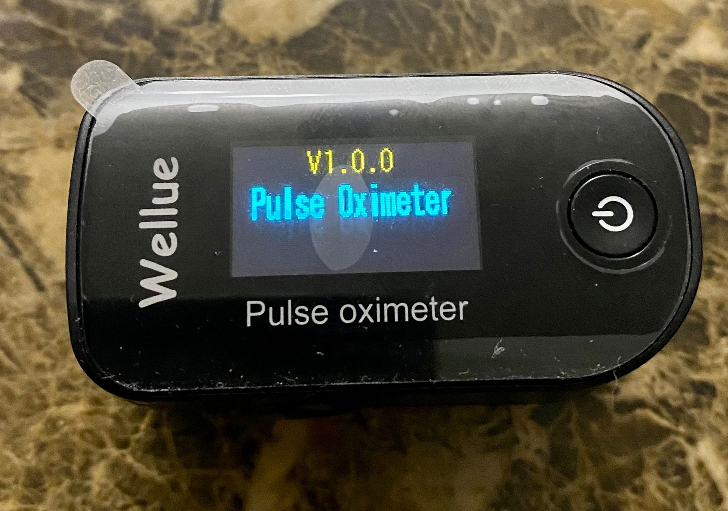  
Figure 6: FS20F Fingertip Pulse Oximeter

1. * 1. The principle of the oximeter is based on an experience formula making use of the Lambert -Beer Law according to Spectrum Absorption characteristics of Reductive hemoglobin (Hb) and oxyhemoglobin (HbO2) in the red and near-infrared zones. The wavelengths used in the fingertip oximeter are shown in Table 1:

|  |  |  |
| --- | --- | --- |
|  | 1. Wavelength | 1. Radiant Power |
| 1. RED |  | 1. 1.8mW |
| 1. IR |  | 1. 2.0mW |

1. Table 1: Channels, their wavelengths and radiant power
   1. The two wavelengths are detected by a sensor that is attached on the human finger tip through a clamp finger-type sensor. The signals are measured by a photosensitive element, and the information will be shown on screen using electronic circuits and a microprocessor. The sensor used is shown in Figure 6

## 4.5 Sphygmomanometer

An OMRON M6 sphygmomanometer is used as ground truth and compared with blood pressure measurements obtained from our proposed method. It comes with an IntelliWrap cuff (22-42 cm), an easy way to get accurate results. It reads three times in a row at 30-second intervals and displays the average value to show blood pressure more accurately. When we press the START / STOP button, the calibration check system lights will come on and the device will start monitoring the readings using the two sensors. If the device is accurate and functioning properly, the calibration check system light will come on during the measurement. If an error is detected, the calibration check system light will flash and the display will show "ER".

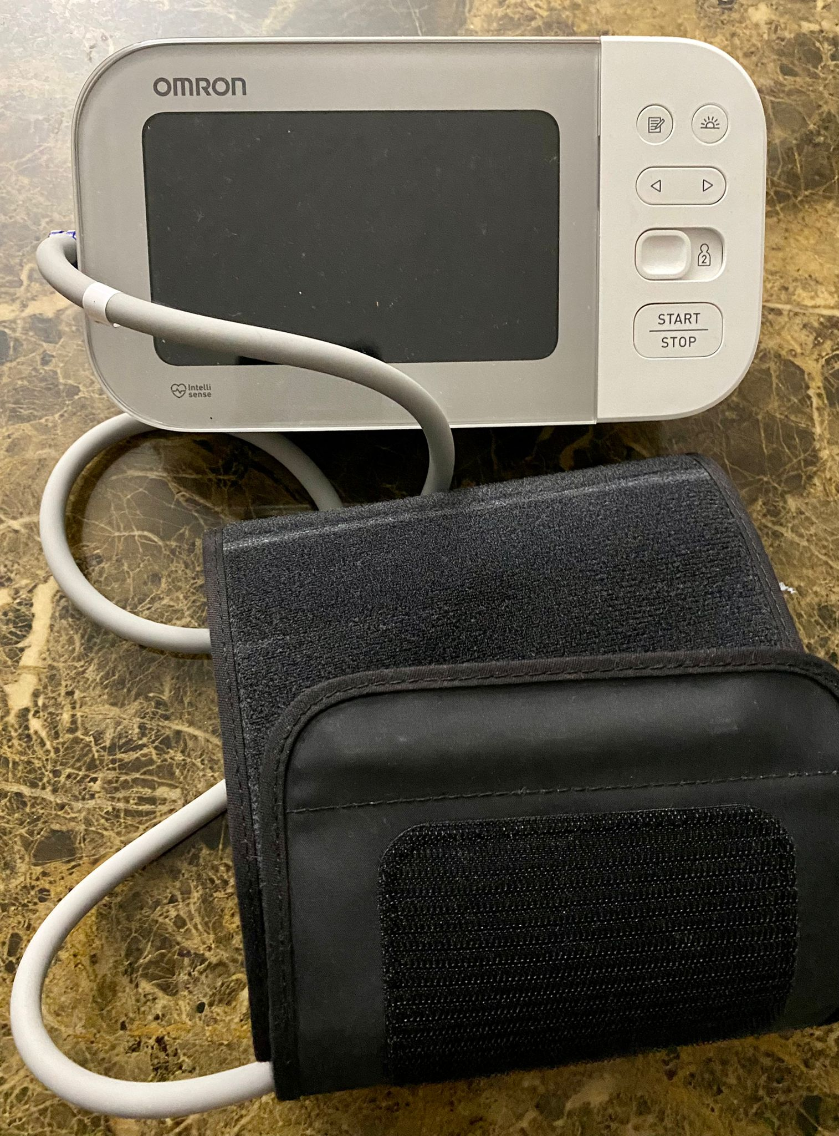  
Figure 7: OMRON M6 sphygmomanometer

The monitor calculates the average reading based on the three most recent sets of measurement values taken within 10 minutes of the most recent reading. The accuracy is $±3mmHg$ or 2% of reading.

The cuff inflates until it fits snugly on the arm, blocking blood flow. Then the valve opens to release the air. When the cuff reaches contraction pressure, blood begins to flow around the arteries. This causes vibrations picked up by the gauge and records systolic pressure. In a traditional analog sphygmomanometer, a stethoscope is used by a doctor to record the sound of blood. As the cuff continues to contract, the cuff reaches diastolic pressure, and vibration stops. The gauge recognizes this and records the pressure again.

# Chapter 5 Methods

## 5.1 Data Capture and Facial Landmark Extractor

A multi-spectral RGB-NIR camera (AD-080-GE) at 30 fps is used to capture videos for our tests. The videos are exported in uncompressed format. One video is recorded in color and the other in NIR synchronously.

Figure 8: Data Capture sample from multi-spectral camera



To reliably locate regions of interest in the image that have significant blood flow close to the skin (in our case the cheeks), facial landmarks are detected by analyzing the frames of the video. Salient, reliably identifyable regions of the face like eyes, eyebrows, nose, mouth, and jawline are detected from this analysis. Key points are used for face alignment, head pose estimation, face swapping, and blink detection. We acquire the face bounding box (i.e., the (x,y) coordinates of the face in the image). To register the face and determine head pose, we estimate the location of 68 (x,y) coordinates which helped map to the facial structures on the face as shown in Figure 10. From this, we determine a bounding box for the detected face in each frame that, together with the key salient points are then used to determine the locations of the cheek regions as areas with significant blood flow and thus ideal regions for PPG data extraction. For the right and the left cheek, we used two bounding boxes as regions of interest [8].

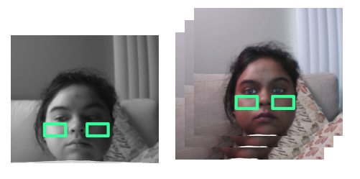  
Figure 9: Bounding boxes( ROIs) in left and right cheek

A spatial average of the color channel and IR channel pixel values (0-255) within the selected ROIs were calculated framewise to form raw signals x 1 (t), x 2 (t)..., x R (t) respectively (where R is channels of the image processed). In our case, we used four as we have considered four channels: red, blue, green, and near-infrared.

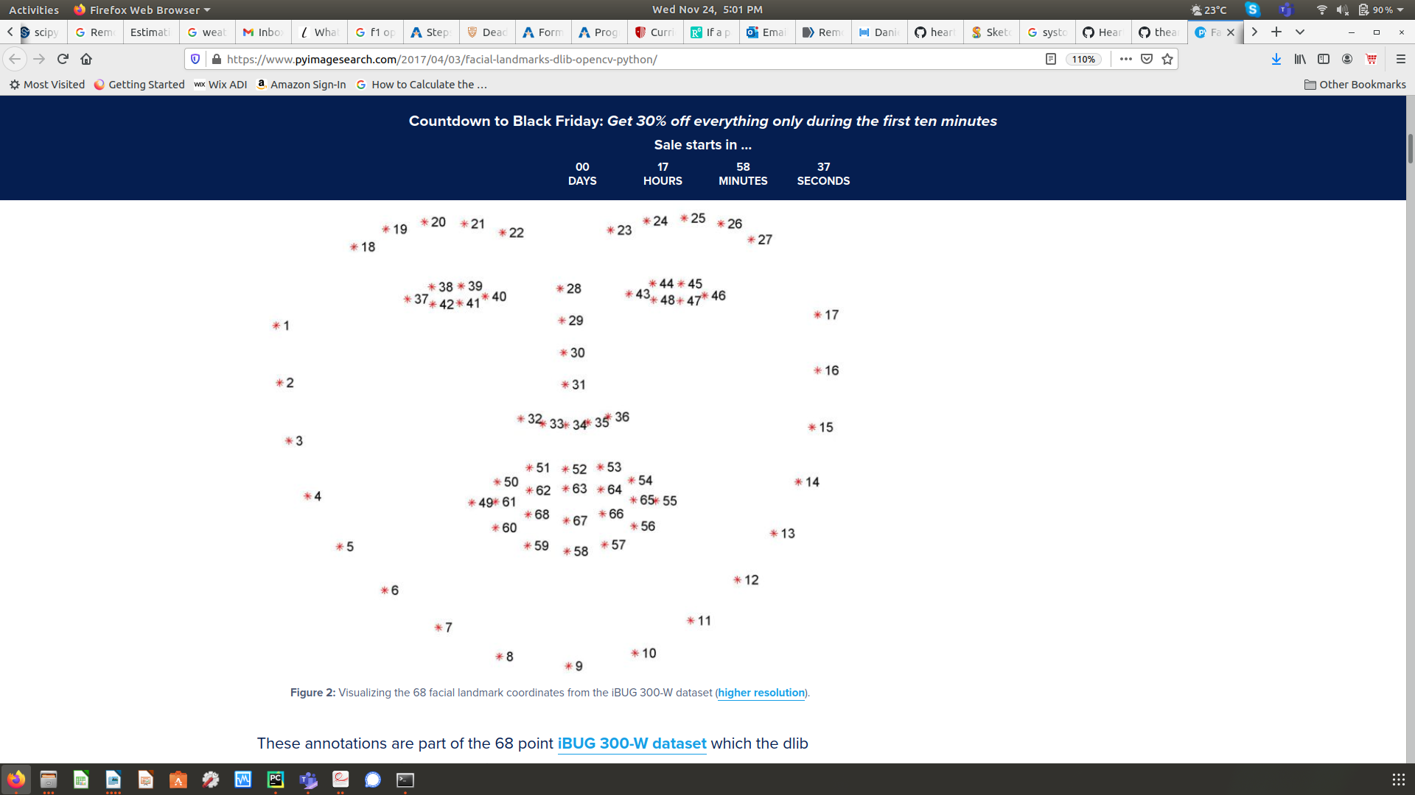  
Figure 10: Visualizing 68 facial landmarks coordinates

## 5.2 Extract signals

Once we read data from the webcam generating digital images, the amount of light received by the camera in a particular pixel location is represented by a numerical value. The skin consists of capillary beds which are close to the skin surface. It is easy to identify such blood-filled capillary beds and we can derive a rectangular region from those areas. This area will help see the photoplethysmogram (PPG). A PPG is a waveform corresponding to the blood pulse through the body over time. The reflected light varies with the amount of blood in the capillary bed at any one given time. This is the origin of the PPG waveform since the light is absorbed by the skin. Our webcam captures images at 30 frames per second. This frame rate will help determine the noise ratio.

After the data components are in place, we create a graphical user interface to display the signals from the webcam pulse-reading algorithm to be able to verify that we obtain good data and to make it easier to analyze later processing results. Here we used a Python for its excellent data visualization capabilities and the open-source development and sharing in the Python community. This is the area where the real-time signal from the webcam can be seen. Using the camera, data is acquired in the following format:

* Light intensity is given as an 8-bit value in grayscale
* Intensity ranges from 0-255
* Signals update in real- time
* Intensity of “region of interest” (ROI) calculated for each image

We detect the boundaries of the face using the Dlib landmark detector [7] on the average face location. Frame-by-frame detection is performed since the subject is assumed to be mobile. An example is shown in Figure 9. We then divide the area inside the detected face into two regions of interest.

## 5.3 Pre-processing (RGB-NIR Camera)

Facial landmarks are detected and the skin region of interest (ROI) is segmented excluding the region around the eyes. We can select as many ROIs as we want but we have taken only 2 ROIs. The spatial average of each color channel in the ROI over time was calculated. Then the source signals, should be filtered. Our first step is to process the Raw PPG signals we have. Every frame in the image consists of RGB channels and IR channels. All PPG signals were filtered using Butterworth high bandpass and low bandpass with orders 2 and 4, respectively. The systolic and diastolic peaks in the contact measures could be visually verified since there is no clinically approved ground-truth method for automatic detection of PPG systolic and diastolic peaks. The red, green, and blue signals are already aligned having maxima and minima at the same time (s). While the IR channel is a little shifted. So, align the IR channel with the Red channel.

The alignment routine named phase-spectra is used. It uses phase correlation in Fourier space. The only caution about this phase correlation is if we cross-correlate data at the native resolution we can achieve integer precision. To achieve sub-pixel or fraction precision, we need to upscale the data before doing cross-correlation. We can upscale data N times to achieve 1/N precision as far as shift value goes. For instance, if N =100 then the smallest shift we can get is 0.01. I am interested in comparing the shift between two signals IR and Red (being strongest signals) that happen to be astrophysical spectra at two different wavelength regions.

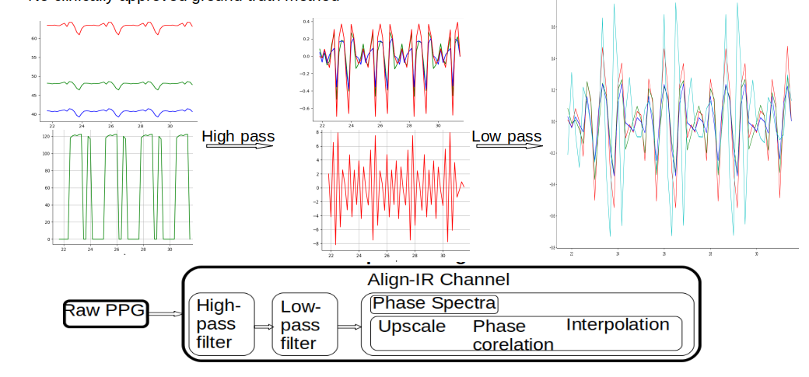  
Figure 11: Filtering of signal

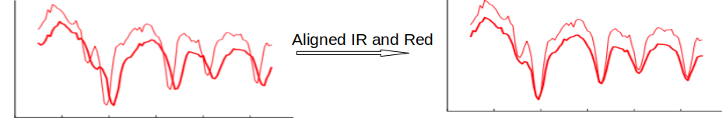  
Figure 12: Aligning Red and IR channel

The strongest BVP signal is selected and inverted if inverted signals are stronger. The systolic peaks are detected as discussed above then the second-order derivative of the BVP waveform is calculated and used to locate the dicrotic notch and diastolic inflection point.

## 5.4 Feature Extraction (RGB-NIR Camera)

The systolic peaks can be detected precisely from filtered waveforms. The maxima of the signal are considered to be the systolic peak. We use a peak detection algorithm to locate peaks for each channel. However, the detection of diastolic peaks is very difficult due to the reason that they are not always maxima. To find the diastolic peaks, we have to compute a second-order derivative of the waveform. As we do not have a continuous function, the derivative calculations are approximated by difference functions on each of the signals. Mostly, the largest minima with second-order derivatives correspond to systolic peaks, and minima following these correspond to diastolic peaks. The locations of systolic peaks are detected and peak detection is performed on an inverted second-order signal using a peak detection algorithm where a peak is a maximum that is greater than the previous value. The diastolic peak timing is located as the minimum timing after the systolic peak in each pulse. The systolic and diastolic peak-to-peak is considered to be one beat.

In a similar way to the diastolic peak we estimate the dicrotic notch and diastolic inflection point. From the filtered spatial average of each color channel in the ROI overtime, the second-order derivative of the BVP waveform is calculated and used to locate the dicrotic notch and diastolic inflection point.

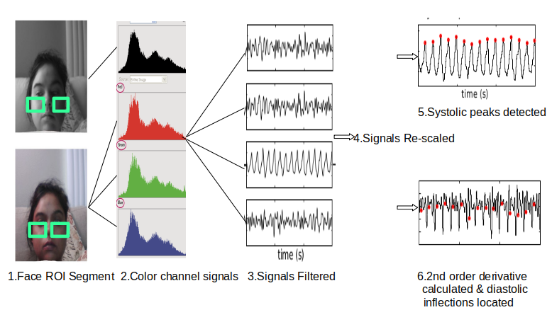  
Figure 13: Signal Extraction from video images

Figure 13 shows an example of this process from identified regions of interest (ROI) through color channel signals to filtered PPG signals and extracted points.

# Chapter 6 Extra Steps for Blood Pressure

Estimation of blood pressure values from PPG data is a slightly more involved process as there is no simple analytic formula to translate PPG key features such as inter-peak timings to blood pressure values. As a result, the translation from the extracted key PPG features to blood pressure estimates is learned using a machine learning algorithm. As this generally requires a significant amount of data, we utilize a separate dataset with PPG and blood pressure data collected using commercial devices to learn this translation function for the PPG feature set that we are extracting from the camera images. For this, the same features as for the camera are extracted from the larger PPG data set and the system is trained based on those parameters to predict the systolic and diastolic blood pressure. Once this function is trained, it is applied to the features extracted from our multi-spectral camera and obtained estimates are evaluated.

## 6.1 UCI Dataset

Due to the limited dataset to train the model, we use PPG signals from UCI for training our model. This cuff-less BP dataset used for the training of our proposed method is available in the Machine Learning Repository of the University of California, Irvine (UCI). There are 12000 signal parts of recorded ECG, PPG, and Arterial Blood Pressure (ABP) collected from 1000 individuals. The data is already pre-processed and validated. PPG signals are used as input and the target values are ABP signals. For testing, we use signals obtained from our proposed method.

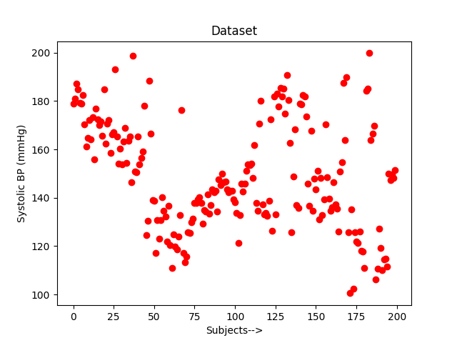  
Figure 14: Training Dataset for Systolic BP

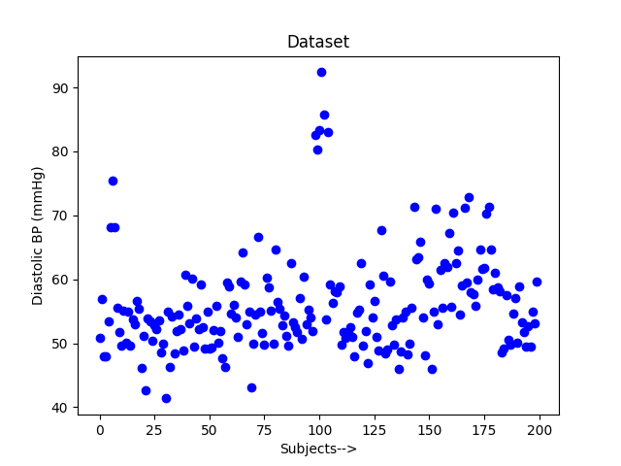  
Figure 15: Training Dataset for Diastolic BP

The dataset was collected from Physionet’s Multi-Parameter Intelligent Monitoring in Intensive Care Units (ICUs). It is also named MIMIC II [11]. The sample training data for 150 randomly selected individuals for systolic and diastolic blood pressure are shown in Figure 14 and Figure 15, respectively.

## 6.2 Pre-Processing (UCI Dataset)

The UCI dataset which we use for training our model is already pre-processed. Some pre-processing and validation has previously been done by Kachuee et al. [12]. The sampling rate is 125 Hz, which is high enough to extract the features of the PPG signal. These PPG signals are relatively long so we have to implement techniques to extract features by dividing signals into small parts

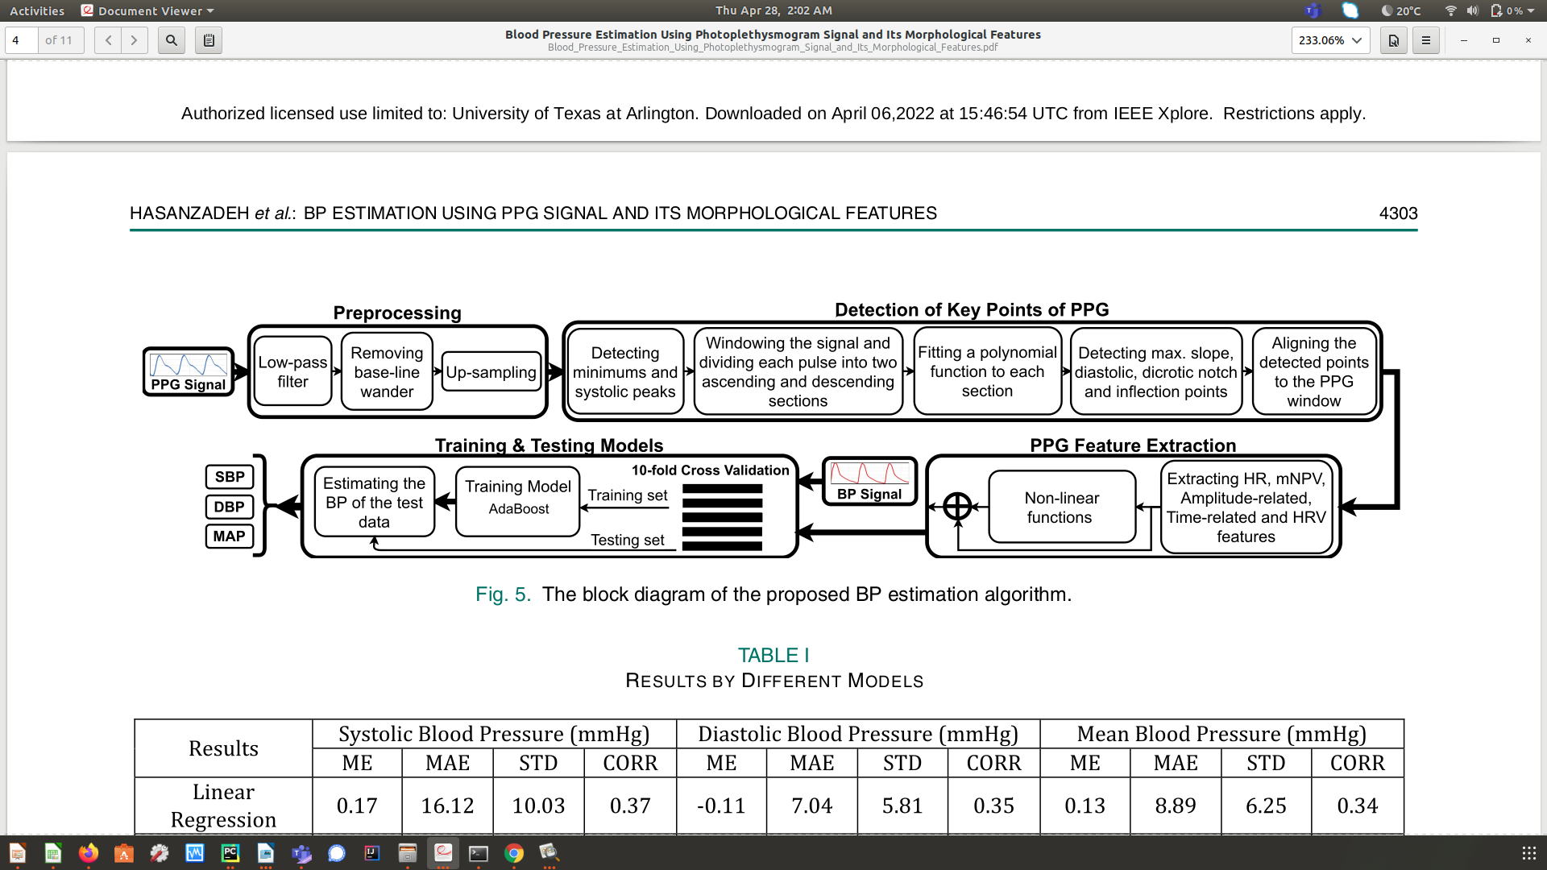  
Figure 16: Pre-processing (UCI Dataset)

## 6.3 Feature Extraction (UCI Dataset)

All the key points required in our approach are basically amplitude related features. That’s the reason, the peak-to-peak amplitude is normalized to 1. And amplitude of diastolic peak, maximum slope point, inflection point and dicrotic notch are to be calculated.

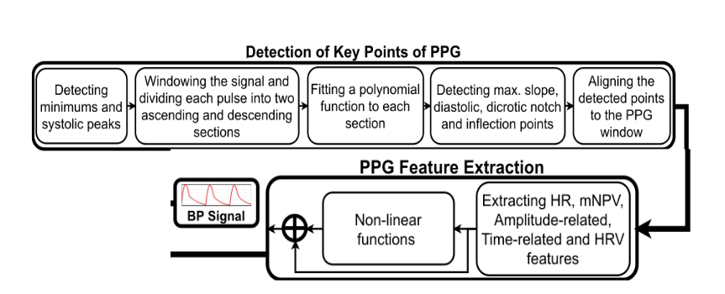  
Figure 17: Feature Extraction (UCI Dataset)

### 6.3.1 Minimum Point and the Systolic Peak Detection [9]:

Various analytical methods such as window thresholding techniques, Hilbert and wavelet transform combinations, artificial neural networks, and Kalman filters are used to detect the maximum and minimum points. The performance of these methods is highly dependent on parameters such as thresholds and window length. Here we used the automatic multiscale base peak detection (AMPD) method. This helped detect periodic and quasi-periodic signal peaks.

The AMPD algorithm has an automatically selected a window value that does not need to be specified in advance. The window size is automatically changed from the minimum possible value to the maximum possible value. The maximum value is selected as the final window size. The maximum value for each window is selected as one of the signal peaks. We apply this method to a sample PPG signal. Short-term fluctuations in the DC current of the signal do not affect the performance of the algorithm. It detects the minimum point and systolic peak, selects the systolic pulse between the two consecutive minimum and normalizes the amplitude to 1. The selected pulse is split into two sections. The first section is the minimum point to the systolic peak, then from the systolic peak to the end, called the ascending and descending sections, respectively.

### 6.3.2 Maximum Slope Point Detection [9]:

For the maximum slope, which is the upward part of the pulse, we used the first derivative of the PPG pulses. This is necessary to remove unwanted noise and artifacts that were not filtered out in the first place. We fit a polynomial of order 5 (largest derivative) to the increment of the pulse to accurately detect the point with the greatest slope.

### 6.3.3 Diastolic Peak Detection:

The diastolic peak is difficult to discern in some PPG pulses, hence the second derivation if the PPG signal is additionally extracted [4]. First, we fit the polynomial to the falling part of the waveform. We choose a degree of on the UCI data 7 for a better fit. The diastolic peak is the point at which the first derivative of the polynomial is zero and the second degree is negative. If such a point is not detected, the point at which the second derivative is the local minimum is chosen as the diastolic peak.6.3.4 Dicrotic Notch Detection: The dicrotic notch is a point where the second derivative of the filtered PPG signal is a local maximum and is located before the diastolic peak.

# Chapter 7 Blood oxygen saturation

SPO2 is the ratio of hemoglobin carrying oxygen to the total amount of hemoglobin in the blood. The normal value of SPO2 varies from 96% to 100%. Generally, a non-invasive pulse oximeter is estimating this based on the absorption of light at different wavelengths by oxyhemoglobin and deoxyhemoglobin. Two Light Emitting Diodes (LEDs), a light detector, and a microprocessor are used to detect infrared and red light absorption. The infrared and red light is absorbed significantly stronger by oxyhemoglobin and de-oxyhemoglobin, respectively. The detector detects the reflected light and uses the difference in intensity at the two wavelengths to estimate SPO2%.

Estimation of the SPO2 value relys on the fact that wavelengths in the Red part of the spectrum are absorbed significantly more by oxyhemoglobin than the ones in the infrared part of the spectrum as indicated in Figure 5. The wavelength for each channel in our data is different. For red, the wavelength is 660 nm, for green 520 nm, for blue 440 nm, and for infrared 940 nm and above. In this range, the Quantum Efficiency (QE) is different for each channel, but the difference in response between oxyhemoglobin and deoxyhemoglobin is largest for the infrared compared to the Red.

SPO2 % is evaluated by monitoring the variation of the light intensity in the Red and infrared color channels. As at the wavelength red and infrared the oxy- and the deoxy-hemoglobin show greater differences in the absorption, a suitable procedure is proposed to extract the PPG from two wavelengths red and infrared. These wavelengths correspond to the ones used in the pulse oximeter.

## 7.1 Proposed Method (SPO2):

Red and IR are used for SPO2 estimation. The accurate evaluation of both the shape and the amplitude of the PPG signals is essential. To estimate SPO2, we calculated the height of the systolic peak Vpλ and the slope of the systolic peak mλ where λ is each color channel considered for calculation. Both oxy- and deoxy-hemoglobin are correlated to shape parameters. The mean value of SPO2% is obtained by taking into consideration all the pulses of the available PPG.

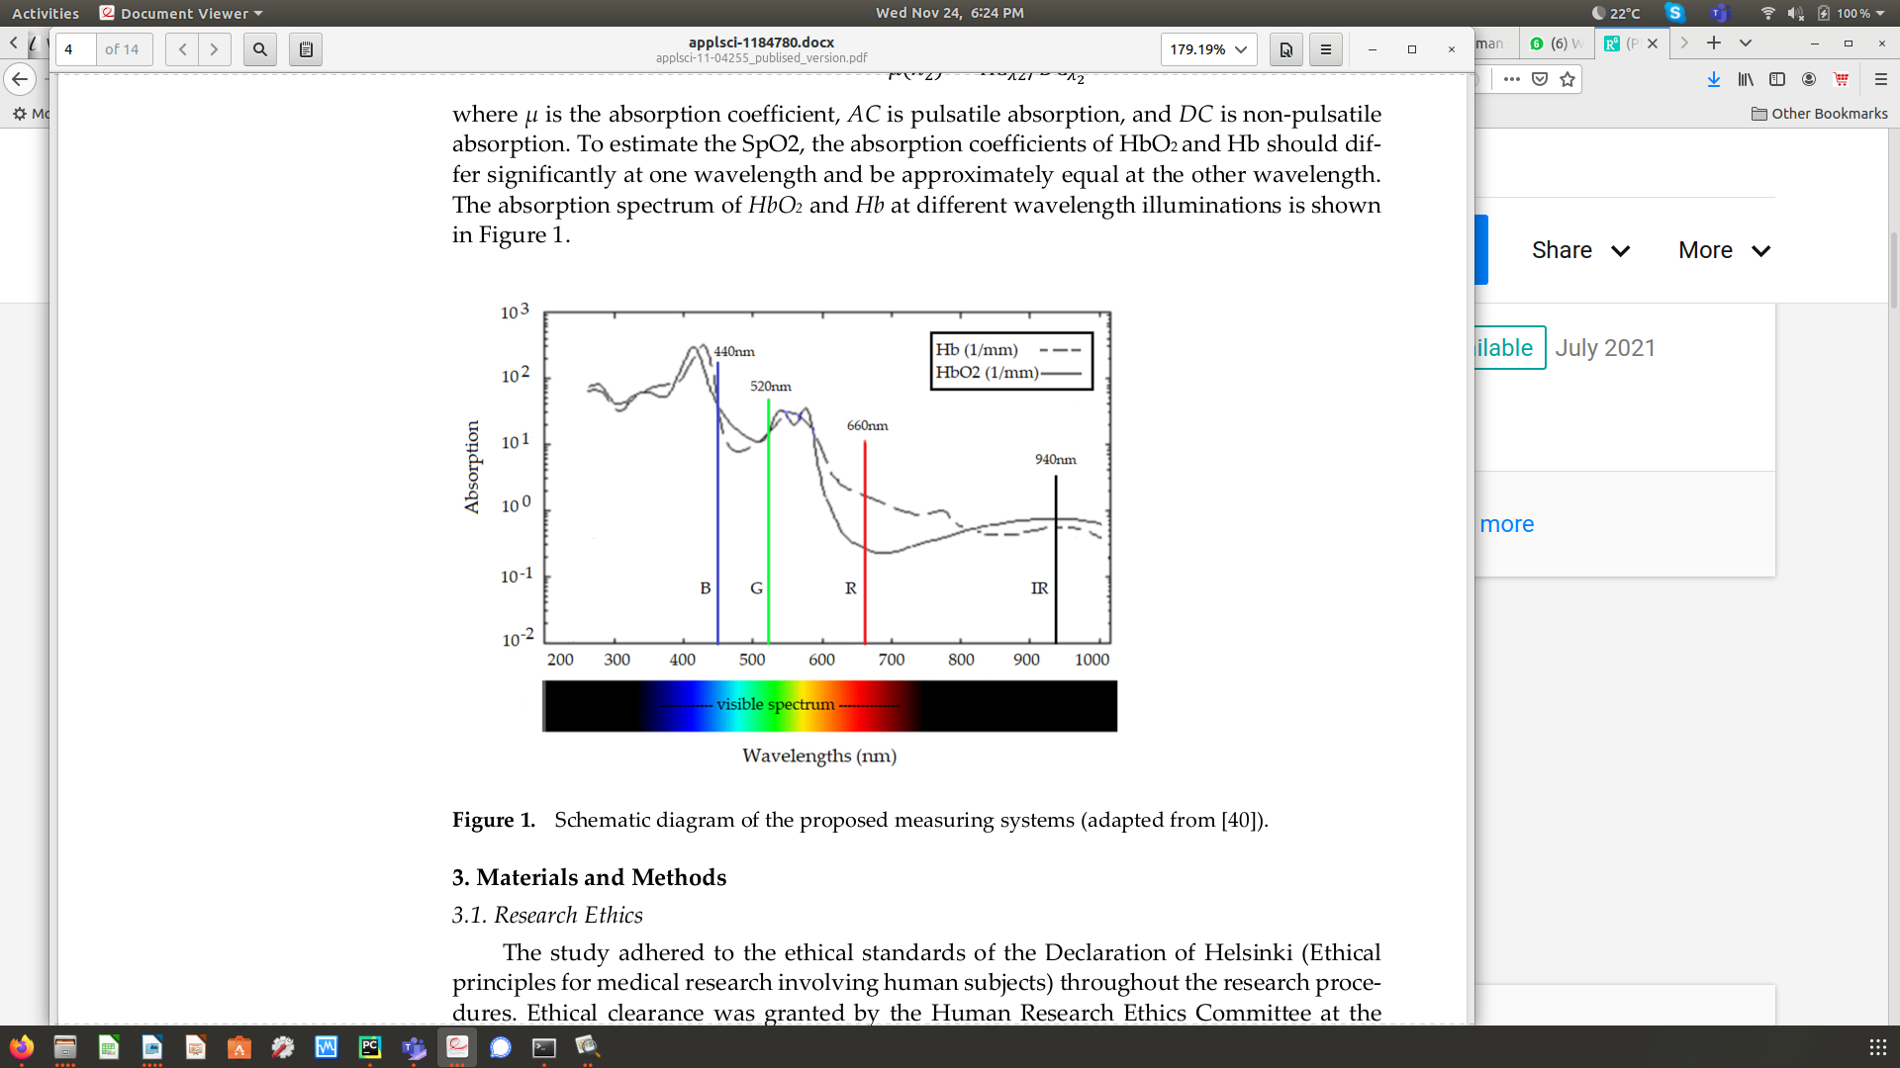  
Figure 18: Absorption coefficients of Oxyhemoglobin(HBO2) and De-Oxyhemoglobin(HB) for different channels

Oxygen level was calculated for each beat according to equation (1) where $ϵ_{Hb}$, and $ϵ_{HbO2}$ denote the absorption coefficients of deoxyhemoglobin and oxyhemoglobin, respectively for each wavelength λ.

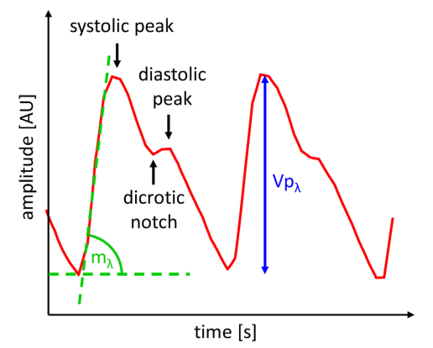  
Figure 19: Slope of the rising edge of the systolic peak mλ and the height of the peak Vpλ

For calculation, the signals red and IR were required.

${SPO}_{2}=\frac{ε_{Hb},_{IR}\sqrt{m_{R}ln\left({Vp}_{R}\right)}−ε_{Hb},_{R}\sqrt{m_{IR}ln\left({Vp}_{IR}\right)}}{\sqrt{m_{R}ln\left({Vp}_{R}\right)}\left(ϵ_{Hb},_{IR}−ϵ_{HbO2},_{IR}\right)−\sqrt{m_{IR}ln\left({Vp}_{IR}\right)}\left(ϵ_{Hb},_{R}−ϵ_{HbO2},_{IR}\right)}$ (1)

The result of SPO2 was calculated by Eq. (2), which was created using the signals. The constant μ is calculated as a mean of errors between the results of the training signals and the reference value and used to determine the final SPO2 estimate:

${SPO}_{2}\left(\text{\%}\right)={SPO}_{2}∗100±μ$ (2)

The constant μ is calculated as a mean of errors between the results of the signals and the readings obtained from commercial oximeter.

# Chapter 8 Blood Pressure

## 8.1 Proposed Method (BP)

Arterial BP is usually measured in two extremes, namely the highest named systolic and lowest named diastolic. These values oscillate around 120/70 mmHg. PPG signals are very sensitive to motion and photosensitive. They must be recorded accurately or can be easily corrupted. If the BP is abnormal, key features won’t be detected in a PPG signal.

For our study, we used algorithms that help extract the key features of a PPG signal effectively. We used more features to accurately present our findings. The proposed method consists of the following steps:

1. De-noising and removing baseline wandering,
2. detecting the key features of PPG signals,
3. feature extraction from PPG signal,
4. training estimation model using UCI MIMIC II dataset.

## 8.2 Training and Testing Models

To train the BP estimation models, we normalized all the features to zero-mean and univariance. We used Linear Regression, Decision Tree, Random Forest with a size of 100 trees and AdaBoost with the size

of 200 decision tree estimators to estimate each of the systolic and diastolic BPs. Additionally, we use the 10-fold cross validation method in order to divide the UCI data for training.

Once the models were trained, they were applied to corresponding feature vectors extracted from our multi-spectral camera and 2-fold cross validation was used in order to divide our data for testing. The lower fold number here is a consequence of the significantly smaller dataset available.

  
Figure 20: Training and Testing Models

# Chapter 9 Results

## 9.1 Oxygen Saturation Results

To validate the proposed procedure, commercial pulse oximeter FS20F Fingertip Oximeter has been used and compared to the readings obtained by RGB-NIR camera. The normal range for oxygen saturation varies from 96-100%.

In the experiment, the multi-spectral camera is positioned on the face. Moreover, to get the results as accurate as possible, the volunteer should be in a rest position with a constant source of light both for colored and infrared image recordings. The volunteers are seated on the chair and their arms are resting on the desk.

The test results are compared in table 2. Healthy volunteers are used in this investigation.The volunteers are seated and at rest position. Both readings are calculated synchronously. Pulse oximeter on the left forefinger and multi-spectral camera video recording at the same time. Table 2 is the comparison of individual readings between pulse oximeter and readings estimated from our proposed method for each volunteer.

|  |  |  |
| --- | --- | --- |
|  | SPO2% pulse oximeter | SPO2% RGB-NIR Camera |
| Subject 1 | 98 | 96.4 |
| Subject 2 | 97 | 97.4 |
| Subject 3 | 99 | 97.5 |
| Subject 4 | 98 | 98.5 |
| Subject 5 | 99 | 96.5 |

Table 2: Comparison of results(SPO2)

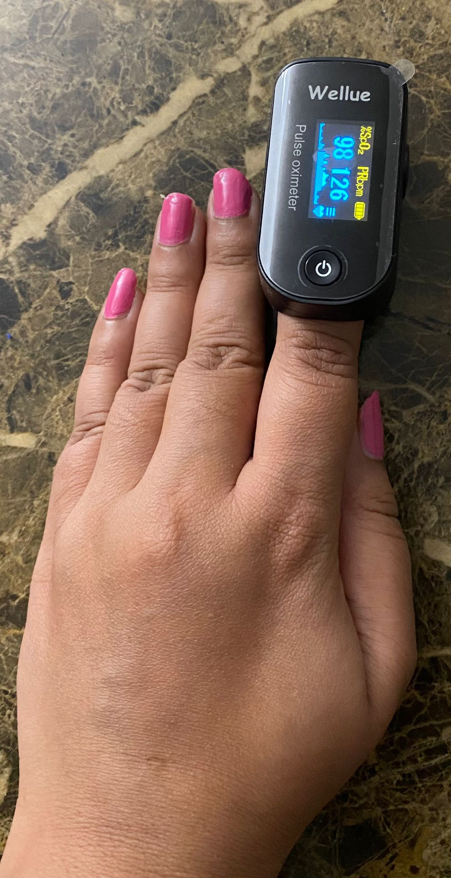  
Figure 21: Pulse oximeter Reading sample

Table 2 shows the result of arterial oxygen saturation for healthy individuals varies between 96% to 99%. Mean Absolute Error calculated is 1.3 and Standard Deviation calculated is 0.85. These fluctuations are due to monitoring of the individual from a distance of 16-30 inches. The fluctuations in readings have been recorded both for pulse oximeter and multi-spectral camera.

The light is the primary interference to be considered because it affects PPG in an unpredictable way. PPG’s amplitude-related feature vary non-linearly with the change in intensity of light or shadows. That’s the reason, in the proposed solution immobility has been considered. The person should sit still with fix source of light. Also, estimates seem to be lower on average, potentially suggesting an offset due to side effects of reflection or glare. However, the data set collected here is not sufficient to determine if this is the case and a significantly larger data set would be needed in the future to answer this question.

## 9.2 Blood Pressure Results

To validate the proposed procedure, the commercial Sphygmomanometer has been used and compared to the readings obtained by the RGB-NIR camera. The test results are compared in table 3. Healthy volunteers are used in this investigation. The volunteers are seated and at rest position. Both readings are calculated synchronously. Sphygmomanometer on the left arm and multi-spectral camera video recording at the same time.

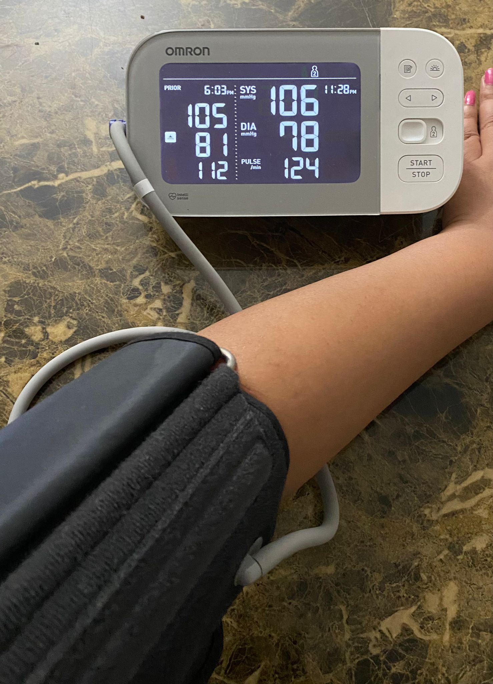  
Figure 22: BP reading sample

Table 3 shows the result of systolic and diastolic blood pressure for healthy individuals varies between 50 – 200 mmHg. These fluctuations are due to monitoring of the individual from a distance of 16-30 inches.

|  |  |  |  |  |
| --- | --- | --- | --- | --- |
| Results | Systolic BP(mmHg) | | Diastolic BP(mmHg) | |
| MAE | STD | MAE | STD |
| Linear Regression | 29.67 | 0.9 | 13.0 | 0.5 |
| Decision Tree | 60.75 | 6.6 | 5.5 | 5.0 |
| Random Forest | 47.1 | 5.0 | 5.0 | 4.0 |
| AdaBoost | 38.5 | 5.7 | 6.8 | 0.76 |

Table 3: Results by Different Models

We need supervised learning algorithms to estimate values of blood pressure as it allows collecting data and gives an output from previous experiences. We have labels and features from the UCI dataset to get output from our proposed method. We used different supervised learning models to estimate each of the systolic and diastolic blood pressures. These models are Linear Regression, Decision Tree, Random Forest, and Adaboost. Random forest with a size of 100 trees and Adaboost with a size of 200 decision trees have been employed to predict values. Most of the BP values in UCI Dataset are around normal values.

In Table 3, Mean Absolute Error (MAE) and Standard Deviation (STD) for each model used has been shown. Based on these results in Table Decision tree and Random Forest methods have surpassed methods like Linear Regression and Adaboost for diastolic BP, while Linear Regression and Adaboost performed better on systolic PB as compared to Decision and Random Forest. However, Table 2 shows also shows significant variations. In particular, the result of systolic and diastolic blood pressure for healthy individuals varies between 50 – 200 mmHg. Part of these fluctuations are due to monitoring of the individual from a distance of 16-30 inches. What can be noticed here is that while the diastolic BP can be estimated with a MAE of around 5 here, which might be an acceptable value, the system has significantly more problems extracting systolic BP values with MAEs of around 30 in the best case. This suggests that the parameters needed for systolic blood pressure are not extracted sufficiently precisely from the camera and thus additional work to filter the PPG signal across wavelengths needs to be performed in the future to make the system more precise.

# Chapter 10 Conclusions and Future Work

As we conclude our study, we presented an automated method for systolic and diastolic blood pressure, blood oxygen saturation measurement using the PPG waveform which was captured from the RGB and NIR images from our camera. The numbers help understand the cardiac health of the subject and the usability of multi-wavelength lights. Using state of the art combinations of camera and algorithms for processing the data, we have verified the proposed solution for cardiac measurements.

Defining the operational envelope of PPG measurement using RGB-NIR camera is important and there is a trade-off between camera lens, illuminating device and distance at which measurements were taken with almost similar accuracy [8].

The arterial stiffness which is the root cause of arteriosclerosis can be detected with the help of PPG of both RGD and IR images since the correlation of arterial elasticity and the reflection or the absorption of PPG signals. For different age groups the PPG signals are different.

Current detection of SPO2 is done with the help of pulse oximetry which consists of contact-based sensors which may cause discomfort or infection for sensitive skin.

In terms of SPO2 measurements, the experiments suggest that our proposed system displays similar results as oximeters and is relatively cost effective. In terms of blood pressure, on the other hand, the system achieved acceptable results for diastolic BP but struggled with estimating systolic BP. This indicates that our system can be used partially for estimation of SPO2, BP and HR. However, additional work is needed to further clean the extracted PPG signal by merging more efficiently across different wavelength channels. Also, a multi-spectral camera with a higher frame rate might help improve parameter estimation and filtering.

# References

[1] J. Allen, “Photoplethysmography and its application in clinical physio-logical measurement,” Physiological measurement, vol. 28, no. 3, p. R1,2007.

[2] J. Allen, C. P. Oates, T. A. Lees, and A. Murray, “Photoplethysmography detection of lower limb peripheral arterial occlusive disease: a comparison of pulse timing, amplitude and shape characteristics,” Physiological measurement, vol. 26, no. 5, p. 811, 2005.

[3] A. M. Brumfield and M. E. Andrew, “Digital pulse contour analysis: in-vestigating age-dependent indices of arterial

[4] K. Takazawa, N. Tanaka, M. Fujita, O. Matsuoka, T. Saiki, M. Aikawa,S. Tamura, and C. Ibukiyama, “Assessment of vasoactive agents and vascular aging by the second derivative of photoplethysmogram waveform,” Hypertension, vol. 32, no. 2, pp. 365–370, 1998

[5] M.-Z. Poh, D. J. McDuff, and R. W. Picard, “Non-contact, automated cardiac pulse measurements using video imaging and blind source separation,” Optics Express, vol. 18, no. 10, pp. 10 762–10 774, 2010.

[6] ——, “Advancements in noncontact, multiparameter physiological mea- surements using a webcam,” Biomedical Engineering, IEEE Transac-tions on, vol. 58, no. 1, pp. 7–11, 2011.

[7] D. McDuff, S. Gontarek, and R. Picard, “Improvements in remote cardio-pulmonary measurement using a five-band digital camera,” Biomedical Engineering, IEEE Transactions on, vol. 61, no. 9, 2014.

[8] J. J. Oliver and D. J. Webb, “Noninvasive assessment of arterial stiffness and risk of atherosclerotic events,” Arteriosclerosis, Thrombosis, and Vascular Biology, vol. 23, no. 4, pp. 554–566, 2003.

[9] N. Hasanzadeh, M. M. Ahmadi and H. Mohammadzade, "Blood Pressure Estimation Using Photoplethysmogram Signal and Its Morphological Features," in IEEE Sensors Journal, vol. 20, no. 8, pp. 4300-4310, 15 April15, 2020, doi: 10.1109/JSEN.2019.2961411.

[10] Andrea Nemcova, Ivana Jordanova, Martin Varecka, Radovan Smisek, Lucie Marsanova, Lukas Smital, Martin Vitek, “Monitoring of heart rate, blood oxygen saturation, and blood pressure using a smartphone” in Biomedical Signal Processing and Control, vol. 59, 2020, 101928, ISSN 1746-8094, <https://doi.org/10.1016/j.bspc.2020.101928>.

[11] A. L. Goldberger et al., “PhysioBank, PhysioToolkit, and PhysioNet: Components of a new research resource for complex physiologic sig- nals,” Circulation, vol. 101, no. 23, pp. e215–e220, 2000.

[12] M. Kachuee, M. M. Kiani, H. Mohammadzade, and M. Shabany, “Cuffless blood pressure estimation algorithms for continuous health- care monitoring,” IEEE Trans. Biomed. Eng., vol. 64, no. 4, pp. 859–869, Apr. 2017

[13] Al-Naji A, Khalid GA, Mahdi JF, Chahl J. Non-Contact SpO2 Prediction System Based on a Digital Camera. Applied Sciences. 2021; 11(9):4255.https://doi.org/10.3390/app11094255

[14] Y. Kurylyak, F. Lamonaca, D. Grimaldi, in: R.J. Duro, F.L. Peña (Eds.), Smartphone-Based Photoplethysmogram Measurement in Digital Image and Signal Processing for Measurement Systems, River Publishers, 2012, pp. 135–164

[15] H. Luo, et al., Smartphone-based blood pressure measurement using transdermal optical imaging technology, Circ. Cardiovasc. Imaging 12 (2019), e008857, <http://dx.doi.org/10.1161/CIRCIMAGING.119.008857>

[16] I. Tayfur, M.A. Afacan, Reliability of smartphone measurements of vital parameters: a prospective study using a reference method, Am. J. Emerg. Med. 37 (2019) 1527–1530, http://dx.doi.org/10.1016/j.ajem.2019.03.021

[17] C. Gavriel, K.H. Parker, A.A. Faisal, Smartphone as an ultra-low cost medical tricorder for real-time cardiological measurements via ballistocardiography, Proceedings of the 2015 IEEE 12th International Conference on Wearable and Implantable Body Sensor Networks (BSN) (2015), http://dx.doi.org/10.1109/ BSN.2015.7299425

[18] F. Landreani, et al., Heartbeat detection using three-axial seismocardiogram acquired by mobile phone, Comput. Cardiol. (2018), http://dx.doi.org/10. 22489/CinC.2018.215

[19] S.A. Siddiqui, Y. Zhang, Z.Q. Feng, A. Kos, A pulse rate estimation algorithm using PPG and smartphone camera, J. Med. Syst. 40 (2016) 126, http://dx.doi.org/10.1007/s10916-016-0485-6

[20] B.R. O’Driscoll, L.S. Howard, J. Earis, V. Mak, BTS guideline for oxygen use in adults in healthcare and emergency settings, Thorax 72 (2017), http://dx.doi.org/10.1136/thoraxjnl-2016-209729

[21] F. Lamonaca, et al., Blood oxygen saturation measurement by smartphone camera, Proceedings of the IEEE International Symposium on Medical Measurements and Applications (MEMEA 2015) (2015) 359–364, http://dx.doi.org/10.1109/MeMeA.2015.7145228

[22] K.E. Barret, S.M. Barman, S. Boitano, H.L. Brooks, Ganong’s Review of Medical Physiology, The McGraw-Hill Companies, Inc, 2010

[23] Chandrasekaran, R. Dantu, S. Jonnada, S. Thiyagaraja, K.P. Subbu, Cuffless differential blood pressure estimation using smart phones, IEEE Trans. Biomed. Eng. 60 (2013) 1080–1089, http://dx.doi.org/10.1109/TBME.2012.2211078.

[24] A. Dias, S. Murali, F. Rincon, D. Atienza, Methods for reliable estimation of pulse transit time and blood pressure variations using smartphone sensors, Microprocess. Microsyst. 46 (2016) 84–95, http://dx.doi.org/10.1016/j.micpro.2016.06.001.

[25] S.S. Mousavi, et al., Blood pressure estimation from appropriate and inappropriate PPG signals using a whole-based method, Biomed. Signal Process. Control 47 (2019) 196–206, http://dx.doi.org/10.1016/j.bspc.2018.08.022.

[26] J. Dey, A. Gaurav, V.N. Tiwari, InstaBP: cuff-less blood pressure monitoring on smartphone using single PPG sensor, Proceedings of the Annual International Conference of the IEEE Engineering in Medicine and Biology Society (EMBC 2018) (2018) 5002–5005, http://dx.doi.org/10.1109/EMBC.2018.8513189.

[27] Martínez, Natalia et al. “Non-Contact Photoplethysmogram and Instantaneous Heart Rate Estimation from Infrared Face Video.” 2019 IEEE International Conference on Image Processing (ICIP) (2019): 2020-2024.

# Dataset References

1. Cuff-Less Blood Pressure Estimation Data Set :<https://archive.ics.uci.edu/ml/datasets/Cuff-Less+Blood+Pressure+Estimation>

# Biographical Information

Divya Saxena was born in Uttar Pradesh, India. She received a Bachelor of Technology in 2012, after which she worked in Nucleus Softwares Export Ltd., Rlabs Enterprises Service Ltd., Gati KWE, and BlueJay Solutions at senior roles. In August 2019, she entered the University of Texas in Arlington, Texas, to pursue Master of Science in Computer Science. Her current research area is Computer Vision, Neural Networks and Machine Learning.